25.34: a) A voltmeter placed over the battery terminals reads the emf: 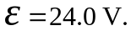
b) There is no current flowing, so 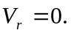
c) The voltage reading over the switch is that over the battery: 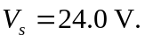
d) Having closed the switch:
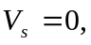 since all the voltage has been “used up” in the circuit. The resistance of the switch is zero so 